

THE ESCAPE ROOM: The FMD infected farm

Examples of questions for the facilitator

**Question One**

FMD carrier animals: A carrier animal is one that become persistently infected after clinical recovery.

Which one of this animals has can play a significant role as a carrier?

1. Cattle
2. Elephants
3. Sheep
4. African buffalo

The answer is:

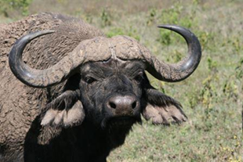

**Question Two**

Which one of these animals release a bigger amount of virus in expired air?

1. Cattle
2. Pigs
3. Humans
4. African buffalo

The answer is:

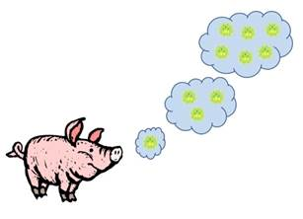

Pigs are seen as important amplifiers of FMD, with the potential to produce vast quantities of airbourne virus.

**Question Three**

If you take a blood sample from Rebecca and make a serological assay, what would you expect to find and why?

1. SP and NSP antibodies
2. SP antibodies
3. NSP antibodies

ANSWER: The answer is that you would find both SP (Structural Protein) and NSP (Non-structural protein) antibodies as she has been infected by FMDv.

When an animal has been vaccinated with a purified FMD vaccine, you would expect to find only SP antibodies, as in the production process of these vaccines, replication proteins (NSP) have been removed and the remaining antigens are those for the capside of the virus (SP). You would never expect to find only NSP antibodies.

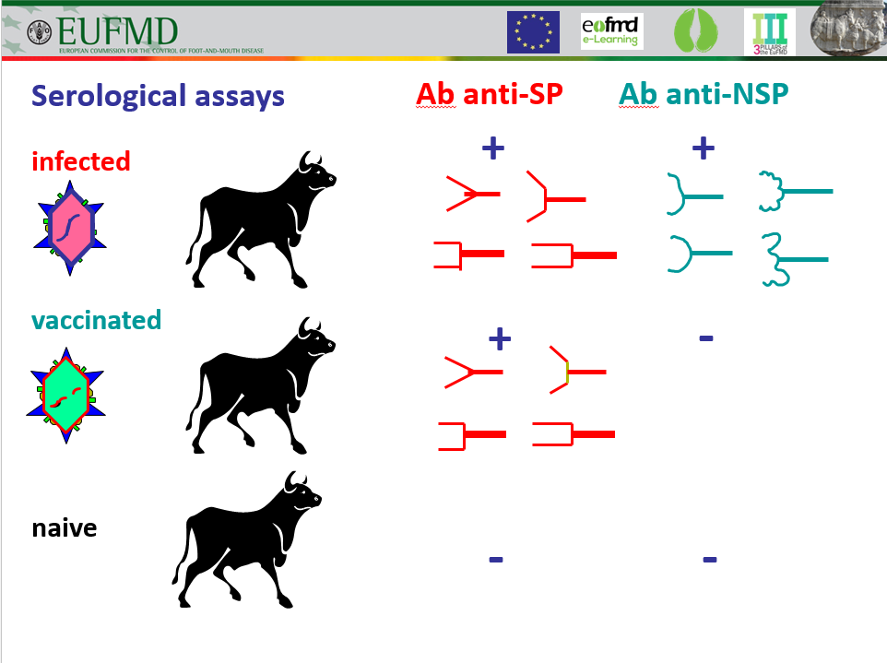

NOTE: You could substitute this question by another one that you consider more relevant related to sampling and laboratory diagnosis. Some examples could be: What kind of sample would you take from Rebecca? ; What laboratory tests would you do to Rebecca? etc.

*.*