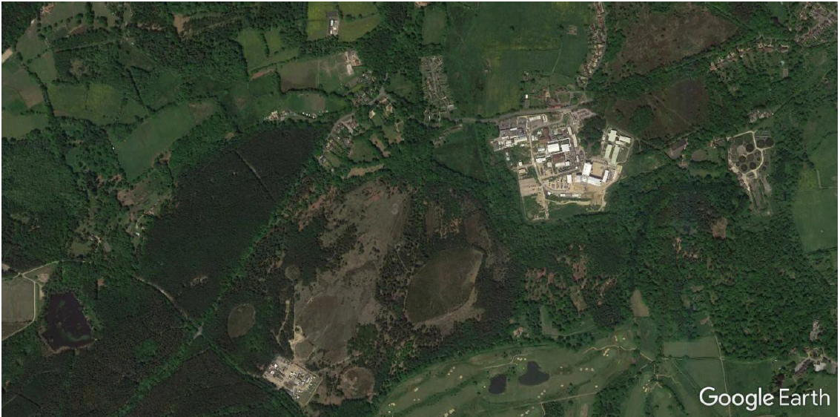
FMD vaccine laboratory

