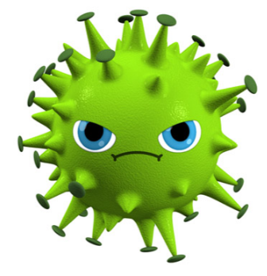

**,** **-**

**Hi! I´m FMDv. I ´m a Supervirus, but I have my KrypHtonite.**

**You ´ll inactivate me if you remember in which range I can survive and you will also have the code to the solution. **