THE ESCAPE ROOM: The FMD infected farm
Game description. Role game for 2-5 people

Learning objectives

This role game will be a useful tool to revise the basis of FMD. In an entertaining way, the knowledge acquired with the FMD emergency preparation course, RTT, induction courses for several workshops or for national trainings developed to cascade down FMD knowledge will be revised.
The specific learning objectives are the following:
- To remember some of the characteristics of EuFMD virus.
- To revise FMD transmission.
- To be able to recognize FMD lesions and age them.
- To revise sampling and laboratory diagnosis.
- To be capable of understanding the use of a timeline and prioritize different contacts.
- To recognize good practices regarding biosecurity.

Aim of the game: You have been called to a farm where there is a suspicion of an FMD outbreak. You have 30 minutes to confirm this and identify the origin of the outbreak. To find the solution, you´ll have to discover the clues and solve the different enigmas.

Materials needed to prepare the game:

- Printed animals on both sides (one side animal/one side lesion).
- Printed copy of the timeline
- Agenda to note several possible contacts
- Printed photo of uncle James
- Three envelopes
- Empty plastic bottle to introduce the clue inside
- Box/luggage with number lock (3 numbers)
- Postcard
- Printed copy of Rebecca on two pages (one page Rebecca/one page lesion)
- Electronic copy of the park
- Biosecurity puzzle (print on both sides and cut as indicated)
- Questions for the facilitator
- Extra material (optional)
- Cello tape
- Laptop

Preparation of the game

You need to prepare the room with the different clues:
- Herd of animals: Print the animals on both sides. Print several times the naïve ones to make a bigger herd. Leave the herd on top of a table, for example.
- Printed copy of the timeline. Leave it in another part of the room.
- Agenda: Write down the following information in the agenda, you will need to take into account the day on which you are playing the role game, which will be considered Day 0. Day -5 is the day when you have the first lesion (but you don´t have to note this in the agenda!). You should note in the agenda the following:
  - Day -3: Livestock market
  - Day -5: Vet coming for insemination
  - Day -9: Uncle James comes to visit me from his farm!!
  - Day -10: Amazon delivers new bike
  - Day -15: Plumber
  - Day -18: Birthday party
  - Day -20: Picnic in the park with Rebecca
Leave the agenda nearby the timeline.
- Three close envelopes: Write in one of them “Livestock market”, in another one “Vet for insemination” and in the third one “Uncles James”. Inside the two first ones put a note with the word “WRONG!!” written on it. In the envelope “Uncle James” you can insert the picture of Uncle James. It is important that the envelopes are close and that it is not possible to see what is inside each of them. Write on the three envelopes, the following sentence (on the side where you can open them): “If this is the wrong option, you will be penalized with minus 5 minutes!” Place the envelopes on a visible place, for example, on a book shelf.
- Printed photo of Uncle James.
- Empty white plastic bottle (one of pasteurized milk could do): Roll and place inside the clue. You will keep the bottle with you until the players find the photo of Uncle James to avoid that they open it beforehand. It is perfect if you can keep it inside a bag near you and once they open the right envelope, you can take it out with dissimulation and hold it in your hands or place it near you.
- Printed clue.
- Box/luggage with numbered lock: you can place it on the floor, in a corner of the room, for example. Leave the postcard and the cello tape inside this box/luggage.
- Postcard: Write the following on the postcard:
“Dear Jenny,
I´m having a fantastic time in …..(wherever the postcard is from), but I´m missing Rebecca. She is so cute! she loves sleeping … (indicate the hidden place)!
See you soon,
Sophie”
- Picture of Rebecca: Print each part of Rebecca on a different page. Create a “false bottom” by sticking the two pages with cello tape (with the printed parts facing out). Place the pieces of the biosecurity puzzle between the two layers of paper.
- Biosecurity puzzle: Print it on both sides and cut it following the lines.
- Laptop showing the initial screen requiring a password to enter. The password will be: FMD. Once the password is introduced, the picture of the park is visible.
- Picture of the park (electronic copy to be used on the laptop)
- Questions for the facilitator: These are questions that the facilitator will have the possibility to use when the players ask him for some help: The facilitator will help them out with some clue or relevant information if the payers answer correctly to one question.
- Extra material: If the game is being done in a place that is familiar to the players, you can add some extra objects or photos to decorate the room.

The game

Before entering the room, you will explain to the participants their mission:

“You are a team of official vets in this region. You have been called to confirm if there is an outbreak of FMD and discover the source of the virus. In a few minutes, you are going to enter Villa Pecora. This is a charming isolated farm on the top of a hill where her owner, Sophie, gives a lot of attentions to her beloved animals.

Some days ago she noticed that some lambs were dying and observed lameness in adult animals and she even mentioned that one or two animals showed a quite severe disease. She called a friend who is a vet and when this friend advised her to contact the official vets because it could be FMD, she was so stressed that currently she is in hospital. Therefore, you cannot talk to her, but you will be able to make an investigation in her property to solve this case.

You only have 30 minutes to confirm the suspicion and discover the source of the disease, as there are many calls attending from other farmers,…

In Sophie´s farm you will find her animals and different clues. You will need to examine her animals and solve some puzzles to find the solution. Consider that there are objects in the room that might not be clues. Also, if you make some mistakes, you could be penalized.

In the case you are completely lost at some point, I could help you, but in exchange you will need to correctly answer to a question that I’ll pose”

The players are invited to start by examining the animals. The facilitator of the game stays in the room, but will have a passive role, allowing the players to solve the case by themselves.

Nevertheless, if the facilitator sees that the players are missing something important, he/she will intervene to give some help or will make a question to the participant, so he/she can give help as an exchange to the correct answer.

The facilitator will also be regularly informing the players about the remaining time.

They can find the clues in a different order, but this is the foreseen flow of the game:
- The herd of animals. They find the animals with lesions and age them.
- Use of the timeline to determine the most probable dates when the disease could have been introduced in the farm.
- The agenda is examined and the different events noted are cross-checked with the timeline. It is decided that the visit of Uncle James is the most probable source of introduction of the disease.
- They open the correct envelope and find the picture of Uncle James.
- It is observed that the bottle that Uncle James has in his hands is very similar to the one that the facilitator is now holding (or that it is placed near him/her)
- Once the players open the bottle, they find a clue inside. The virus is resistant between 6.5 and 9. Therefore the code to open the lock is 659.
- Once the luggage is open, and they find the postcard, the players will directly go to find the place where Rebecca sleeps so be careful to hide her well, so they cannot find her before they read the postcard).They will also find cello tape inside the luggage.
- Rebecca is a mini-pig!! The lesions she has will lead the players to reconsider the possible contacts noted in the agenda.
- It is identified that the park could be the source.
- Besides this, the players realize that there is a false bottom in Rebecca´s picture. They open it and find the pieces of the puzzle.
- The players put the pieces of the puzzle together. To do this, they need to decide on good and bad practices of the biosecurity procedure to enter a farm where there is a suspicion of FMD. They should use the cello tape that was inside the luggage to put the pieces together and then on the other side of the sticked-together pieces, the following will be readable: “passwordFMD”.
- The players unlock the laptop using the password ‘FMD’ and find the picture of the park with an indication of the FMD vaccine lab. The hypothesis of the group should be that there has been an escape of the virus from the lab and Rebecca got infected when Sophie took her to the park.

It is very important that at the end of the game, there is a revision with the players of the different steps that were followed. This will be useful to revise the learning objectives of the escape room.

Example of setting of a room

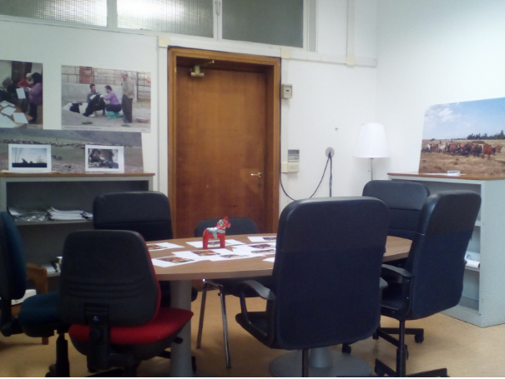
Picture 1. Room used to run the game.

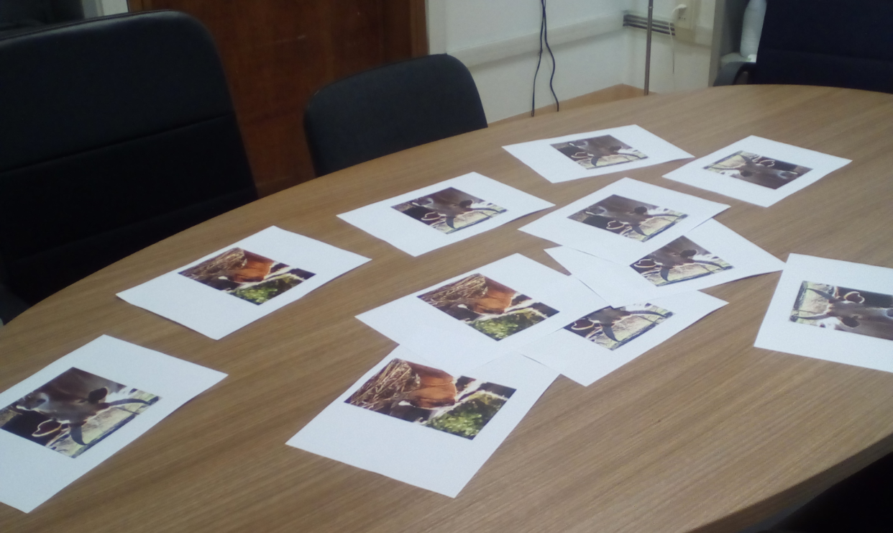
Picture 2. Herd of animals on top of a table.

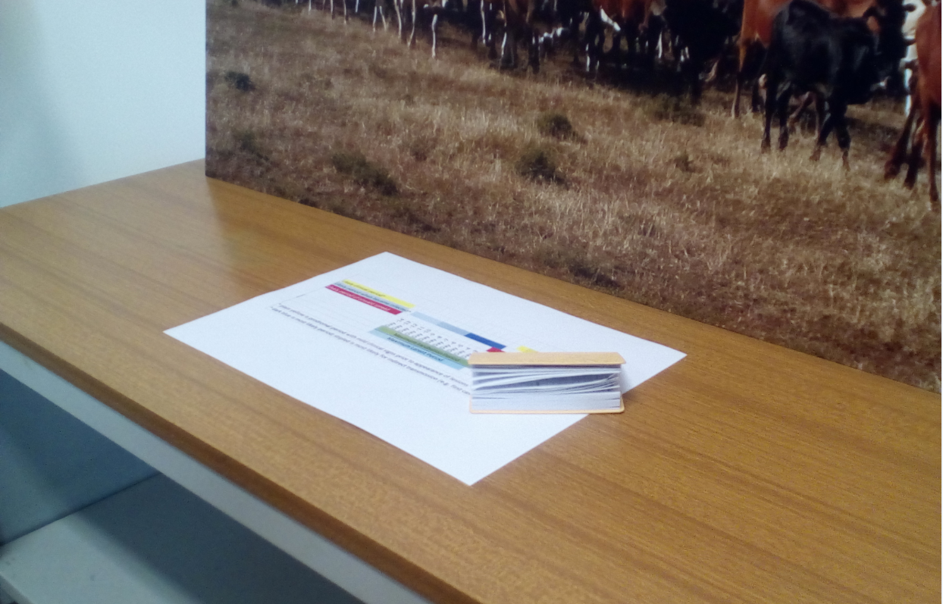
Picture 3. Timeline and agenda.

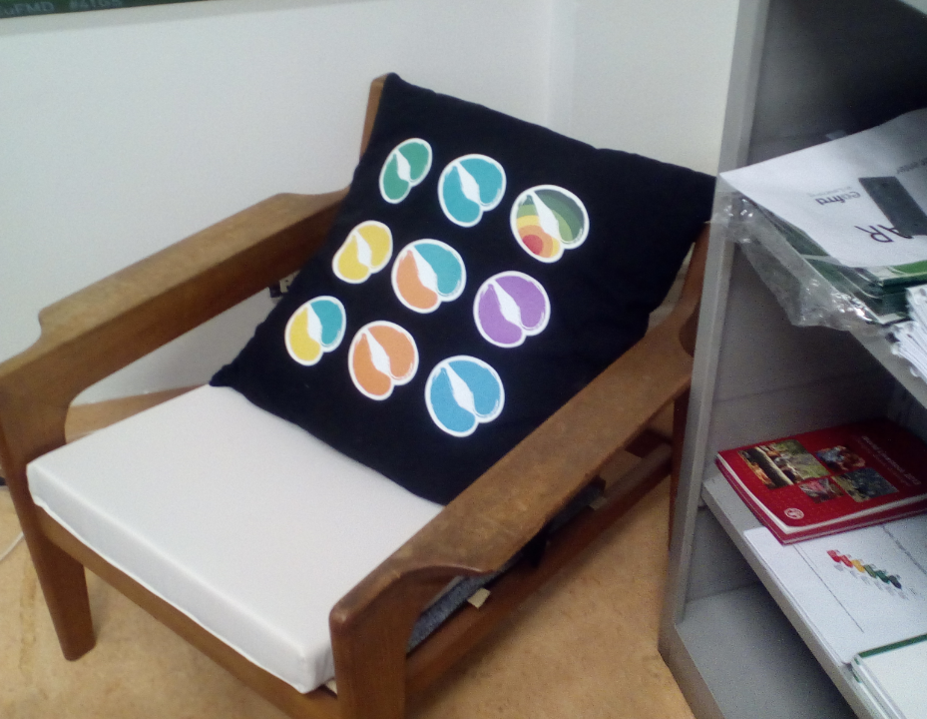
Picture 4. Rebecca is under the white cushion.

